If you are looking for a good book to read, pick up The Bad Beginning by Lemoney Snicket. This book is about children using their smarts to get out of tricky situations.
The story begins when the three Baudelaire children are at a beach and they have just received a terrible message, and it’s up to them to use their heads.
My favorite part was when they are all comfortable and cozy in their neighbor’s library. It proves that no matter how far away from home you are, you can still feel welcome. I’m telling you, once you pick up this book, you won’t be able to put it back down!
If this story doesn’t catch your attention, nothing will! You will be instantly hooked, and want to read the rest of the series.
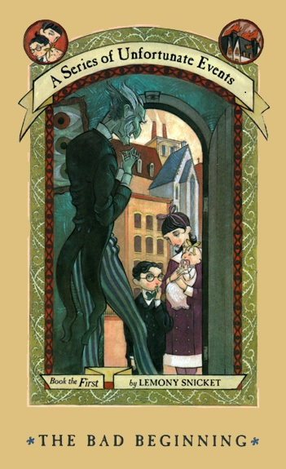
Book review by Reporter Summerfield

